**MYC-JA5D4X **

**ARM** Embedded industrial control CPU module **Product Datasheet**

|  |  |
| --- | --- |
| **Overview** | |
| MYC-JA5D4X CPU Module series is a single board computer base the SAMA5D4, which is a high-performance, power-efficient ARM Cortex-A5 processor MPU capable of running up to 528 MHz. It integrates the ARM NEONTM SIMD engine for accelerated signal processing, multimedia and graphics as well as a 128 KB L2-Cache for high system performance. The device features the ARM TrustZone® enabling a strong security perimeter for critical software, as well as several hardware security features.  The SAMA5D4 features an internal multi-layer bus architecture associated with 32 DMA channels to sustain the high bandwidth required by the processor and the high-speed peripherals. The device supports DDR2/LPDDR/LPDDR2 and SLC/MLC NAND Flash memory with 24-bit ECC.  The comprehensive peripheral set includes a 720p hardware video decoder, an LCD controller with overlays for hardware-accelerated image composition. Connectivity peripherals include a dual 10/100 Ethernet MAC with IEEE1588, three HS USB ports, UARTs, SPIs and I2Cs.  MYIR also offers a variety of mature hardware solutions and rich software resources about Linux operating system. An integrated hardware/software architecture solution allows you to focus on developing applications. | |
| **Product Features** | | |
| ·ARM Cortex-A5 Processor ATSAMA5D43/ATSAMA5D44, frequency up to 528MHz | | |
| ·512MB DDR2 SDRAM,32bit Data bus | | |
| ·512MB Nand Flash/4GB eMMC | | |
| ·4MB Data Flash,64KB EEPROM | | |
| ·10/100M Ethernet MAC Controller | | |
| ·Support USB HOST,USB Device,Ethernet,UART,SPI,I2C,ISI standard interfaces | | |
| ·Support Maximum LCD resolution: 1280 x 720 | | |
| ·Size（67.6mm x 45mm,Thick 1.0mm） | | |
| ·PCB: 8 layer, Flash-Gold, Lead free | | |
| ·Footprint: 200-Pin SO-DIMM | | |
| ·Support Linux3.18 | | |
| **Applications** | | |
| ·Factory and building automation | | |
| ·Smart Grid | | |
| ·Medical and handheld terminal | | |
| ·Smart watches, outdoor GPS | | |
| ·Digital Enhanced Cordless Telecommunications(DECT)phone | | |
| **Customized order** |  |
| ·Offering different memory chips | |
| ·Cropping systems | |
| ·Supporting associated driver development | |
| ·Supporting baseboard development | |

**Revision History**

|  |  |  |
| --- | --- | --- |
| **Version Number** | **Instruction** | **Date** |
| V1.0 | Initial Version | 2015.05.28 |

# Contents

Contents 1

Chapter 1 Overview 2

Chapter 2 Hardware parameters 3

2.1 CPU Feature 3

2.2 Hardware resources Onboard 4

2.3 Extended Interface 5

Chapter 3 Pin Definitions 7

3.1 Pin num 7

3.2 Pin Description 7

Chapter 4 Circuit Design 13

4.1 DDR2 SDRAM 13

4.2 Flash 13

4.2.1 Nand Flash Or eMMC 13

4.2.2 Data Flash 14

4.2.3 EEPROM 15

4.3 Ethernet 15

4.4 LEDs 16

4.5 Power supply 16

4.6 Boot mode 17

Chapter 5 Mechanical parameters 18

Chapter 6 MYD-JA5D4X Development Kit 19

Appendix 1 Warranty & Technical Support Services 20

# Overview

MYC-JA5D4X embedded CPU module, which uses ARM Cortex-A5 ATMEL SAMA5D4X as major processor, is newly designed by Myir. It operates at up to 528MHz, and integrates 512MB DDR2 SDRAM, 512MB NAND Flash Or 4GB eMMC, 4MB Data Flash and 64KB EEPROM memory resources, 10/100MB Ethernet MAC and rich signal interfaces, which compose a Minimum Embedded System. This series of products including two core board, mass customization the user can choose according to need different types of processing chip and industrial or commercial grade device with the appropriate to reduce costs.

* MYC-JA5D43 CPU module（Base on ATSAMA5D43 MPU）
* MYC-JA5D44 CPU module（Base on ATSAMA5D44 MPU,Hardware video decoder）

The MYC–JA5D4X CPU module size is 45mm x 60 mm, Figure 1-1 shows the appearance of the product:

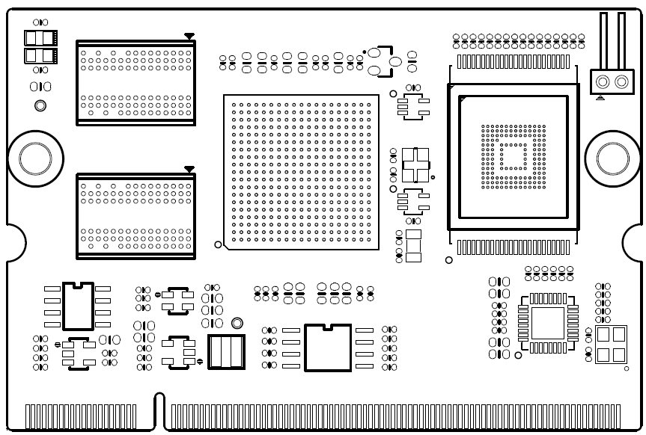

Figure 1‑1 Front view

# Hardware parameters

## CPU Feature

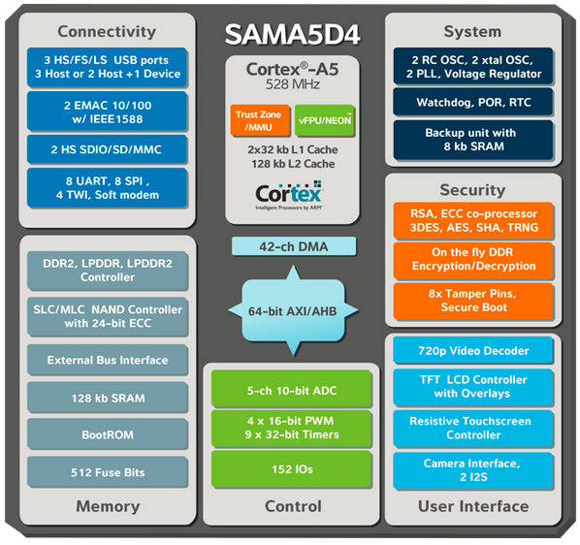

Figure 2‑1 ATSAMA5D4X Architecture

ATSAMA5D4X Series is a high-performance, power-efficient ARM Cortex-A5 processor MPU capable of running up to 528 MHz. It integrates the ARM NEONTM SIMD engine for accelerated signal processing, multimedia and graphics as well as a 128 KB L2-Cache for high system performance. The device features the ARM TrustZone® enabling a strong security perimeter for critical software, as well as several hardware security features. The device also features advanced user interface and connectivity peripherals.

The SAMA5D4 features an internal multi-layer bus architecture associated with 32 DMA channels to sustain the high bandwidth required by the processor and the high-speed peripherals. The device supports DDR2/LPDDR/LPDDR2 and SLC/MLC NAND Flash memory with 24-bit ECC.

The comprehensive peripheral set includes a 720p hardware video decoder, an LCD controller with overlays for hardware-accelerated image composition, a resistive touch screen function, and a CMOS sensor interface. Connectivity peripherals include a dual 10/100 Ethernet MAC with IEEE1588, three HS USB ports, UARTs, SPIs and I2Cs.

## Hardware resources Onboard

MYC-JA5D4X CPU module integrates 512MB DDR2 SDRAM，512MB Nand Flash Or 4GB eMMC,4MB Data Flash and 64KB EEPROM.10/100MB Ethernet PHY, lower number of pins on the SOM and Two LEDs for users. Figure 2‑2 shows the resources of the MYC-JA5D4X CPU module :

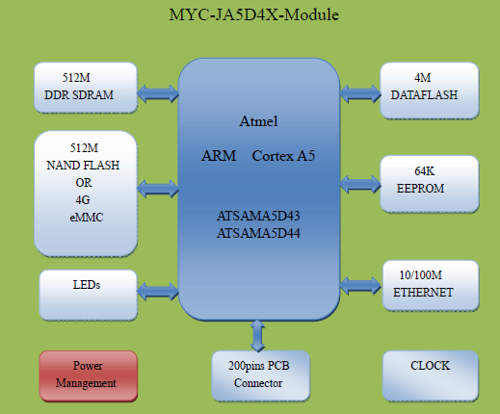

Figure 2‑2 Onboard Resources

## Extended Interface

ATSAMA5D4 havea rich peripheral interface, According to the general applications, MYC-JA5D4X fan out almost all the major pins to the module foot, As much as possible to achieve all function of ATSAMA5D4, Pin multiplexing will be integrated into more number of interfaces on a limited number of pins,See detailed pin functions in *3.2 Pin Description* Table.

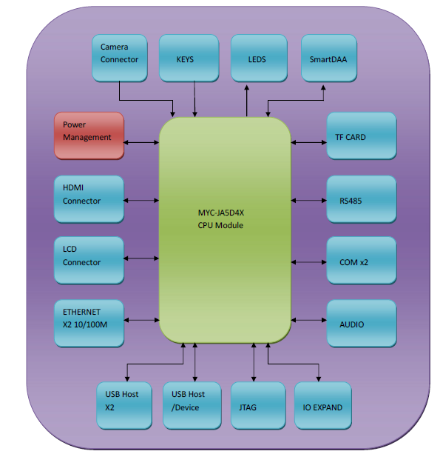

Figure 2‑3 Structure

* NET: Two 10/100MB ethernet MAC controller, internal switch,surport MII and RMII interface
* USB:Three USB2.0，high-speed 480M/s，among them two USB HOST,one MINI USB HOST/Device
* UART: Eight serial, among them debug serial, seven applications serial, can use to RS232 or RS485
* TWI:Four TWI
* SPI:Three McSPI
* ADC:Five 12-bit ADC
* SDIO:Two 4-bit SDIO
* SMD:One SMD interface
* LCD:One 24bit RGB interface
* ISI：One ISI interface
* GPIO：Several port

# Pin Definitions

## Pin num

The next figure show the pin which is the first of MYC-JA5D4X CPU module, and they are sort order.

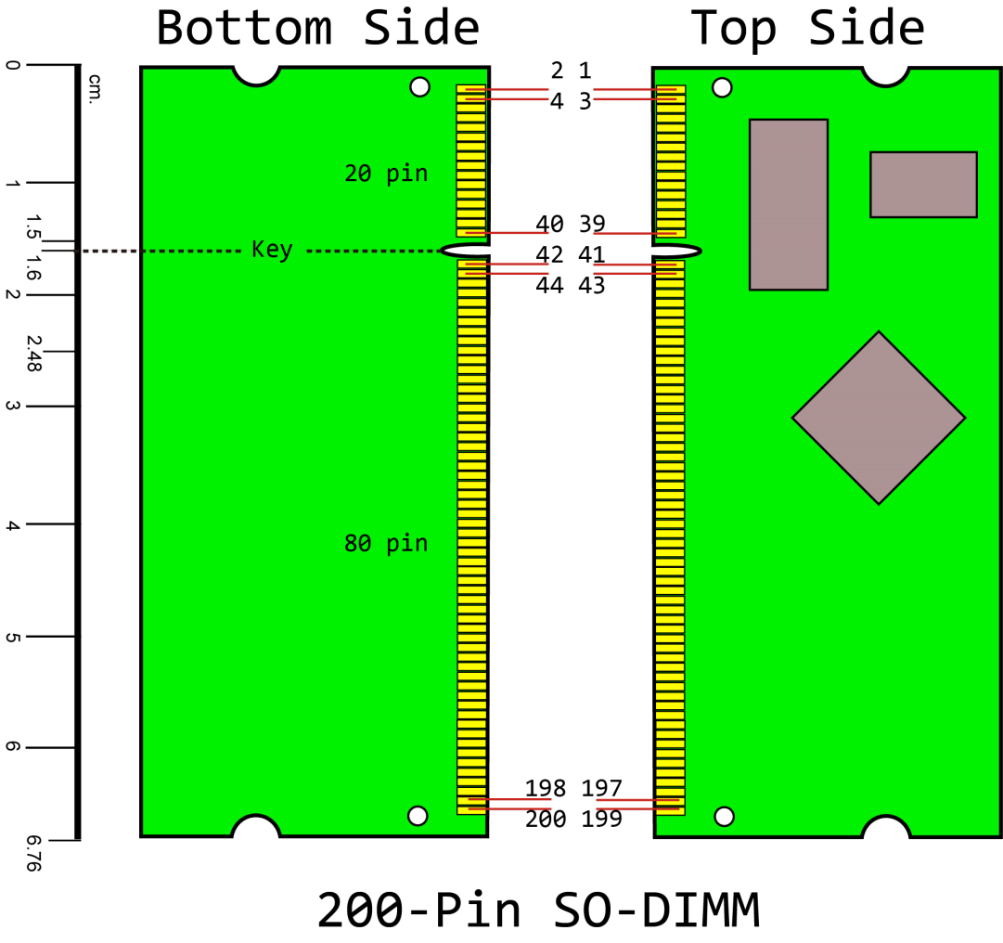

Figure 3‑1 Pin map

## Pin Description

| **Num** | **Signal** | **Peripheral A** | **Peripheral B** | **Peripheral C** | **MYD_JA5D4X** | |
| --- | --- | --- | --- | --- | --- | --- |
| 1 | +5V |  |  |  | 5V Power |  |
| 2 | +5V |  |  |  | 5V Power |  |
| 3 | +5V |  |  |  | 5V Power |  |
| 4 | +5V |  |  |  | 5V Power |  |
| 5 | +5V |  |  |  | 5V Power |  |
| 6 | VDDBU |  |  |  | VDDBU |  |
| 7 | PA0 | LCDDAT0 |  | TMS | LCDDAT0 |  |
| 8 | PA1 | LCDDAT1 |  |  | LCDDAT1 |  |
| 9 | PA2 | LCDDAT2 | G1_TXCK |  | LCDDAT2 | G1_TXCK |
| 10 | PA3 | LCDDAT3 | G1_RXCK |  | LCDDAT3 |  |
| 11 | PA4 | LCDDAT4 | G1_TXEN |  | LCDDAT4 | G1_TXEN |
| 12 | PA5 | LCDDAT5 | G1_TXER |  | LCDDAT5 |  |
| 13 | PA6 | LCDDAT6 | G1_CRS |  | LCDDAT6 |  |
| 14 | GND |  |  |  | Ground |  |
| 15 | VDDIOM |  |  |  | VDDIOM |  |
| 16 | VDDIOM |  |  |  | VDDIOM |  |
| 17 | PA8 | LCDDAT8 |  | TCK | LCDDAT8 | TCK |
| 18 | PA7 | LCDDAT7 |  |  | LCDDAT7 |  |
| 19 | PA10 | LCDDAT10 | G1_RXDV |  | LCDDAT10 | G1_RXDV |
| 20 | PA9 | LCDDAT9 | G1_COL |  | LCDDAT9 |  |
| 21 | PA12 | LCDDAT12 |  |  |  |  |
| 22 | PA11 | LCDDAT11 |  |  |  |  |
| 23 | GND |  |  |  | Ground |  |
| 24 | PA13 | LCDDAT13 | G1_RX1 |  | LCDDAT13 | G1_RX1 |
| 25 | PA14 | LCDDAT14 | G1_TX0 |  | LCDDAT14 | G1_TX0 |
| 26 | PA15 | LCDDAT15 | G1_TX1 |  | LCDDAT14 | G1_TX0 |
| 27 | PA16 | LCDDAT16 |  | NTRST | LCDDAT16 | NTRST |
| 28 | PA17 | LCDDAT17 |  |  | LCDDAT17 |  |
| 29 | PA18 | LCDDAT18 | G1_RX2 |  |  |  |
| 30 | PA19 | LCDDAT19 | G1_RX3 |  |  |  |
| 31 | PA20 | LCDDAT20 | G1_TX2 |  |  |  |
| 32 | GND |  |  |  |  |  |
| 33 | PA22 | LCDDAT22 | G1_MDC |  | LCDDAT22 | G1_MDC |
| 34 | PA21 | LCDDAT21 | G 1_TX3 |  |  |  |
| 35 | PA24 | LCDPWM | PCK0 |  | LCDPWM |  |
| 36 | PA23 | LCDDAT23 | G1_MDIO |  | LCDDAT23 | G1_MDIO |
| 37 | PA26 | LCDVSYNC | PWMH0 | SPI1_NPCS1 | LCDVSYNC |  |
| 38 | PA25 | LCDDISP | TD0 |  | LCDDISP |  |
| 39 | PWR_EN |  |  |  | Power Enable |  |
| 40 | BOOT_CS_OFF |  |  |  | FLASH Enable |  |
| 41 | +3.3V |  |  |  | 3.3V Power |  |
| 42 | +3.3V |  |  |  | 3.3V Power |  |
| 43 | +3.3V |  |  |  | 3.3V Power |  |
| 44 | +3.3V |  |  |  | 3.3V Power |  |
| 45 | PA28 | LCDPCK | PWMH1 | SPI1_NPCS3 | LCDPCK |  |
| 46 | PA27 | LCDHSYNC | PWML0 | SPI1_NPCS2 | LCDHSYNC |  |
| 47 | PA29 | LCDDEN | PWML1 |  | LCDDEN |  |
| 48 | ADCVREF |  |  |  | ADCVREF |  |
| 49 | PA30 | TWD0 |  |  | TWD0 |  |
| 50 | PB3 | G0_TXCK | CTS2 | ISI_VSYNC |  | ISI_VSYNC |
| 51 | PA31 | TWCK0 |  |  | TWCK0 |  |
| 52 | PB5 | G0_COL | TXD2 | PCK2 |  | PCK2 |
| 53 | GND |  |  |  | Ground |  |
| 54 | PB11 | G0_RX3 | RTS2 | PWMH1 |  | ISI_RST |
| 55 | PB1 | G0_RXCK | SCK2 | ISI_PCK |  | ISI_PCK |
| 56 | PB15 | G0_TX3 | SPI2_NPCS2 | PWML0 |  | HDMI_RST |
| 57 | PB4 | G0_CRS | RXD2 | ISI_HSYNC |  | ISI_HSYNC |
| 58 | PB19 | SPI1_MOSI | D9 |  |  | SPI1_MOSI |
| 59 | PB10 | G0_RX2 | PCK2 | PWML1 |  | PCK2 |
| 60 | PB21 | SPI1_NPCS0 | D11 |  |  | SPI1_NPCS0 |
| 61 | PB14 | G0_TX2 | SPI2_NPCS1 | PWMH0 |  | PB14 |
| 62 | GND |  |  |  | Ground |  |
| 63 | PB18 | SPI1_MISO | D8 |  |  | SPI1_MISO |
| 64 | PB23 | SPI1_NPCS2 | D13 |  |  | PB23 |
| 65 | VDDIOP |  |  |  | VDDIOP |  |
| 66 | VDDIOP |  |  |  | VDDIOP |  |
| 67 | PB20 | SPI1_SPCK | D10 |  |  | SPI1_SPCK |
| 68 | PB25 | DTXD | D15 | TDO | TDO | PB25 |
| 69 | PB22 | SPI1_NPCS1 | D12 |  |  | PB22 |
| 70 | PB27 | SPI1_NPCS3 | TK0 | PWML0 |  | TK0 |
| 71 | GND |  |  |  | Ground |  |
| 72 | PB28 | SPI2_NPCS3 | TD0 | PWMH1 |  | TD0 |
| 73 | PB24 | DRXD | D14 | TDI | TDI | DRXD |
| 74 | PB29 | TWD2 | RD0 | PWML1 |  | RD0 |
| 75 | PB26 | PCK0 | RK0 | PWMH0 |  | RK0 |
| 76 | PB30 | TWCK2 | RF0 |  |  | RF0 |
| 77 | PIOBU0 |  |  |  |  | PIOBU0 |
| 78 | PB31 |  | TF0 |  |  | TF0 |
| 79 | PIOBU1 |  |  |  |  | PIOBU1 |
| 80 | GND |  |  |  |  | Ground |
| 81 | PIOBU2 |  |  |  |  | PIOBU2 |
| 82 | PIOBU5 |  |  |  |  | PIOBU5 |
| 83 | PIOBU3 |  |  |  |  | PIOBU3 |
| 84 | PIOBU6 |  |  |  |  | PIOBU6 |
| 85 | PIOBU4 |  |  |  |  | PIOBU4 |
| 86 | PIOBU7 |  |  |  |  | PIOBU7 |
| 87 | PD8 | PCK0 |  |  |  | PCK0 |
| 88 | PD9 | FIQ |  |  | OVCUR_USB |  |
| 89 | GND |  |  |  | Ground |  |
| 90 | PD11 | RTS0 | SPI2_MISO |  |  | RTS0 |
| 91 | PD10 | CTS0 |  |  |  | CTS0 |
| 92 | PD13 | TXD0 | SPI2_MOSI |  |  | TXD0 |
| 93 | PD12 | RXD0 |  |  |  | RXD0 |
| 94 | PD15 | RTS1 | SPI2_SPCK |  |  | RTS1 |
| 95 | PD14 | CTS1 |  |  |  | CTS1 |
| 96 | PD17 | TXD1 | SPI2_NPCS0 |  |  | TXD1 |
| 97 | PD16 | RXD1 |  |  |  | RXD1 |
| 98 | GND |  |  |  | Ground |  |
| 99 | PD18 |  |  |  |  | PD18 |
| 100 | PD19 |  |  |  |  | PD19 |
| 101 | PD20 |  |  |  |  | PD20 |
| 102 | PD21 |  |  |  |  | PD21 |
| 103 | VDDANA |  |  |  | VDDANA |  |
| 104 | VDDANA |  |  |  | VDDANA |  |
| 105 | PD22 |  |  |  |  | PD22 |
| 106 | PD23 |  |  |  |  | PD23 |
| 107 | GND |  |  |  |  |  |
| 108 | PD25 |  |  |  |  | PD25 |
| 109 | PD24 |  |  |  |  | PD24 |
| 110 | PD27 |  |  |  |  | PD27 |
| 111 | PD26 |  |  |  |  | PD26 |
| 112 | PD29 | SCK1 | DIS |  |  | PD29 |
| 113 | PD28 | SCK0 |  |  |  | SCK0 |
| 114 | PD30 |  |  |  |  | PD30 |
| 115 | PD31 | SPI0_NPCS2 | PCK1 |  |  | PD31 |
| 116 | GND |  |  |  | Ground |  |
| 117 | PC0 | SPI0_MISO | PWMH2 | ISI_D8 | SPI0_MISO | ISI_D8 |
| 118 | PC19 | ISI_D0 | TK1 |  |  | ISI_D0 |
| 119 | PC1 | SPI0_MOSI | PWML2 | ISI_D9 | SPI0_MOSI | ISI_D9 |
| 120 | PC20 | ISI_D1 | TF1 |  |  | ISI_D1 |
| 121 | PC2 | SPI0_SPCK | PWMH3 | ISI_D10 | SPI0_SPCK | ISI_D10 |
| 122 | PC21 | ISI_D2 | TD1 |  |  | ISI_D2 |
| 123 | PC3 | SPI0_NPCS0 | PWML3 | ISI_D11 | SPI0_NPCS0 | ISI_D11 |
| 124 | PC22 | ISI_D3 | RF1 |  |  | ISI_D3 |
| 125 | GND |  |  |  | Ground |  |
| 126 | PC23 | ISI_D4 | RD1 |  |  | ISI_D4 |
| 127 | PC4 | SPI0_NPCS1 | MCI0_CK | PCK1 | MCI0_CK | PC4 |
| 128 | PC24 | ISI_D5 | RK1 | PCK1 |  | ISI_D5 |
| 129 | NC |  |  |  |  |  |
| 130 | PC26 | ISI_D7 | TWCK3 | UTXD1 |  | ISI_D7 |
| 131 | PC27 | AD0 | SPI0_NPCS1 | PWML0 | AD0 |  |
| 132 | PC25 | ISI_D6 | TWD3 | URXD1 |  | ISI_D6 |
| 133 | PC28 | AD1 | SPI0_NPCS2 | PWML1 | AD1 |  |
| 134 | GND |  |  |  | Ground |  |
| 135 | PC29 | AD2 | SPI0_NPCS3 | PWMFI0 | AD2 |  |
| 136 | NC |  |  |  |  |  |
| 137 | PC30 | AD3 |  | PWMH0 | AD3 |  |
| 138 | PE30 | DIBN | UTXD0 | TWCK1 | DIBN | PE30 |
| 139 | PC31 | AD4 |  | PWMH1 | AD4 |  |
| 140 | PE29 | DIBP | URXD0 | TWD1 | DIBP | PE29 |
| 141 | VDDIOP |  |  |  | VDDIOP |  |
| 142 | VDDIOP |  |  |  | VDDIOP |  |
| 143 | GND |  |  |  | Ground |  |
| 144 | PE31 | ADTRG |  |  | VBUS_SENSE | PE31 |
| 145 | PE0 | A0/NBS0 | MCI0_CDB | CTS4 | CTS4 | PE0 |
| 146 | PE1 | A1 | MCI0_DB0 |  |  | LED_Blue |
| 147 | PE2 | A2 | MCI0_DB1 |  |  | MCI1_CD |
| 148 | PE3 | A3 | MCI0_DB2 |  |  | INT_HDMI |
| 149 | PE5 | A5 | CTS3 |  | CTS3 | PE5 |
| 150 | PE4 | A4 | MCI0_DB3 |  |  | INT_AUDIO |
| 151 | PE7 | A7 | TIOB3 | PWMFI1 |  | INT_ETH1 |
| 152 | PE6 | A6 | TIOA3 |  |  | PE6 |
| 153 | PE9 | A9 | TIOA2 |  |  | PE9 |
| 154 | GND |  |  |  | Ground |  |
| 155 | PE11 | A11 | TCLK2 |  |  | EN5V_HDB |
| 156 | PE8 | A8 | TCLK3 | PWML3 |  | LED_Red |
| 157 | GND |  |  |  | Ground |  |
| 158 | PE10 | A10 | TIOB2 |  |  | EN5V_HDA |
| 159 | HHSDPA |  |  |  |  | HHSDPA |
| 160 | PE12 | A12 | TIOA1 | PWMH2 |  | EN5V_HDC |
| 161 | HHSDMA |  |  |  |  | HHSDMA |
| 162 | PE17 | A17 | TXD3 | TCLK0 | TXD3 | PE17 |
| 163 | GND |  |  |  | Ground |  |
| 164 | PE16 | A16 | RXD3 | TIOB0 | RXD3 | PE16 |
| 165 | HHSDPB |  |  |  |  | HHSDPB |
| 166 | PE13 | A13 | TIOB1 | PWML2 |  | PB_USER1 |
| 167 | HHSDMB |  |  |  |  | HHSDMB |
| 168 | PE14 | A14 | TCLK1 | PWMH3 |  | INT_LCD |
| 169 | GND |  |  |  | Ground |  |
| 170 | GND |  |  |  | Ground |  |
| 171 | HHSDPC |  |  |  |  | HHSDPC |
| 172 | PE15 | A15 | SCK3 | TIOA0 |  | LCD_RST |
| 173 | HHSDMC |  |  |  |  | HHSDMC |
| 174 | PE18 | A18 | TIOA5 | MCI1_CK |  | MCI1_CK |
| 175 | GND |  |  |  | Ground |  |
| 176 | GND |  |  |  | Ground |  |
| 177 | PE19 | A19 | TIOB5 | MCI1_CDA |  | MCI1_CDA |
| 178 | JTAGSEL |  |  |  | JTAGSEL |  |
| 179 | PE23 | A25 | TCLK4 | MCI1_DA3 |  | MCI1_DA3 |
| 180 | WKUP |  |  |  |  | WKUP |
| 181 | PE25 | NCS1 | SCK4 | IRQ |  | PE25 |
| 182 | SHDN |  |  |  |  | SHDN |
| 183 | PE27 | NWR1/NBS1 | TXD4 |  | TXD4 | PE27 |
| 184 | NC |  |  |  |  |  |
| 185 | GND |  |  |  | Ground |  |
| 186 | nRST |  |  |  |  | nRST |
| 187 | ETH0_RX- |  |  |  | ETH0_RX- |  |
| 188 | PE20 | A20 | TCLK5 | MCI1_DA0 |  | MCI1_DA0 |
| 189 | ETH0_RX+ |  |  |  | ETH0_RX+ |  |
| 190 | PE21 | A23 | TIOA4 | MCI1_DA1 |  | MCI1_DA1 |
| 191 | ETH0_TX- |  |  |  | ETH0_TX- |  |
| 192 | PE22 | A24 | TIOB4 | MCI1_DA2 |  | MCI1_DA2 |
| 193 | ETH0_TX+ |  |  |  | ETH0_TX+ |  |
| 194 | PE24 | NCS0 | RTS3 |  |  | PE24 |
| 195 | GND |  |  |  | Ground |  |
| 196 | PE26 | NCS2 | RXD4 | A18 |  | RXD4 |
| 197 | LED2 |  |  |  | ETH0_LED2 |  |
| 198 | PE28 | NWAIT | RTS4 | A19 |  | 1-WIRE |
| 199 | LED1 |  |  |  | ETH0_LED1 |  |
| 200 | GND |  |  |  | Ground |  |

Table - Pin description

# Circuit Design

## DDR2 SDRAM

MYC-JA5D4X CPU module uses two DDR2 SDRAM chips which type is MT47H128M16RT 128M x 16bit.It’s connected to DDR interface of the ATSAMA5D4X processor:

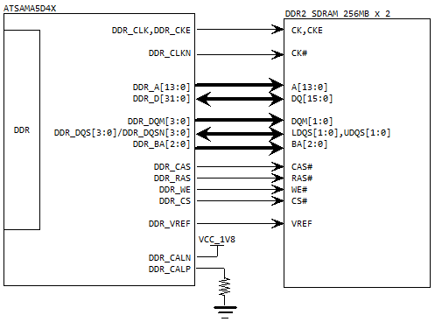

Figure 4‑1 DDR2 SDRAM

## Flash

MYC-JA5D4X CPU module integrated with rich Flash storage space,512 Nand Flash or 4GB eMMC ,4MB Data Flash and 64KB EEPROM.

### Nand Flash Or eMMC

The storage of MYC-JA5D4X have two type, eMMC or Nand Flash, they are pin-compatible. Default, the Nand Flash are pasted. When using the Nand Flash, a single MT29F4G08ABAEAWP Flash Chip connected to PC[18:5] peripheral A of ATSAMA5D4X, the size is 512MB. 8-Bit IO, and other control singals.

The eMMC is a communication and mass data storage device that includes a MMC interface, and a controller on an advanced 11-signal bus, which is compliant with the MMC system specification. It simplified the design, to solve the problems of compatibility. When using eMMC, it connected to PC[13:4] peripheral B of ATSAMA5D4X, 8 data line, the size is 4GB.

MMC0_DA [7:0] and D[7:0] pins are reused ,when leading or driving needs to set different model:

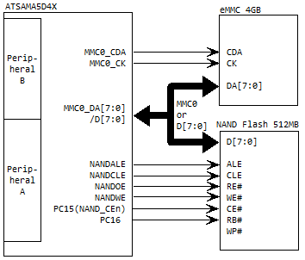

Figure 4‑2 Nand Flase Or eMMC

### Data Flash

MYC-JA5D4X CPU module integrated with a 4MB SPI Flash which type is AT25DF321A-SH-T.It’s connected to PC[3:0] peripheral A of the ATSAMA5D4X.

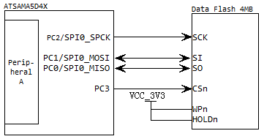

Figure 4‑3 SPI Flash

### EEPROM

MYC-JA5D4X CPU Module is equipped with a 64KB EEPROM, connects to PA[31:30],using TWI0 function peripheral A of ATSAMA5D4X. Can use for store any parameters, bootloader or image.

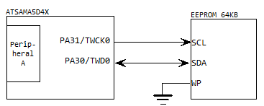

Figure 4‑4 EEPROM

## Ethernet

ATSAMA5D4X supports two Ethernet ports,The Ethernet MAC (GMAC) module implements a 10/100 Mbps Ethernet MAC compatible with the IEEE 802.3standard. The GMAC can operate in either half or full duplex mode at all supported speeds. A PHY chip integrated in the CPU Module. Direct output signal 8 bit line media, and also simplifies the design.

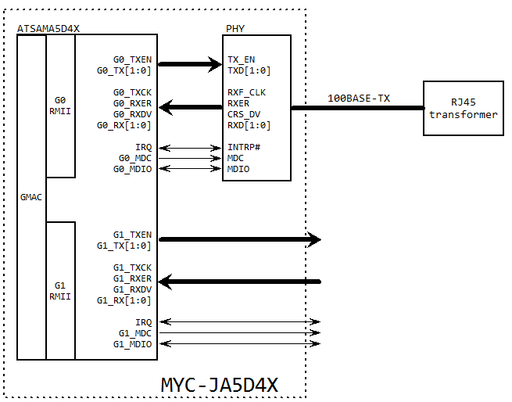

Figure 4‑5 Ethernet

## LEDs

MYC-JA5D4X CPU Module is equipped with two LEDs,Red LED for the system heart which is connected to PB15，Blue LED for the user which is conncted to PB14.

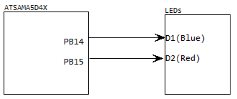

Figure 4‑6 LEDs

## Power supply

MYC-JA5DD4X CPU module has been designed for power management circuits, base board only need to provide 3.3V power supply.

* VDDIOP:Powers the peripherals I/O lines(3.0V-3.6V). Must be established prior to VDDCORE.CPU module already connected to 3.3V.
* VDDIOM :Powers the NAND and HSMC Interface I/O lines(3.0V-3.6V). CPU module already connected to 3.3V.
* VDDBU :Powers the Slow Clock oscillator, the internal 64 kHz RC and a part of the System Controller.Must be established first.Supply ripple must not exceed 30 mVrms. Need base board to provide power(1.88V-2.12V).
* ADCVREF:ADC reference voltage.Need base board to provide power(2.8V-3.6V).
* PWR_EN: The CPU module power input enable signal, high-level power supply. Recommend base board high-level by default.

## Boot mode

◆ CS_BOOT_OFF is Nand Flash and Data Flash enable signal, if low-level voltage, Nand Flash and Data Flash are disabled.If there are default programs in Flash, it will not recognize SAMBA.Therefore, when Flash boot is invalid at low-level voltage, USB can be programmed normally.

When CS_BOOT_OFF signal at high-level voltage,it can select boot mode.

|  |  |  |  |
| --- | --- | --- | --- |
| Number | System defualt | Boot mode | |
| CLOSE | OPEN |
| JP1 | OPEN | Data Flash | Nand Flash |

Table - Boot mode

# Mechanical parameters

* Operating Temperature: Industrial Grade: -40~+85 °C

◆ Commercial Grade: -20~+70°C

* Ambient Temperature: -50～+100°C
* Humidity: 20%~90%, Non-Condensing
* Mechanical Dimensions: [67.6 x 45 x 1.0] mm
* Weight:NA
* PCB: 8 layer, Flash-Gold, Lead free
* Power Input Specification: 3.3V/2A
* Footprint: Perforations, 200 Pin SO-DMII
* System Power Consumption: NA

MYC-JA5D4X series CPU module mechanical dimensions are shown in Figure 5‑1:

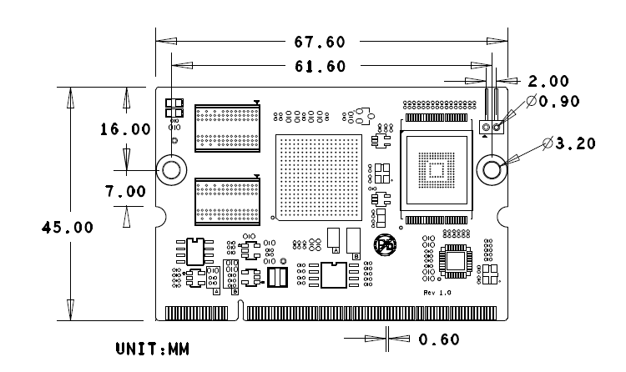

Figure 5‑1 Mechanical Dimensions

# MYD-JA5D4X Development Kit

MYD-JA5D4X is based on ATSAMA5D4X processor’s (SAMA5D43,SAMA5D44) ARM Cortex-A5 core, with frequency up to 528MHz, external expansion 512MB DDR2 SDRAM,512MB Nand Flash or 4GB eMMC,4MB Data Flash,64KB EEPROM. There are two serial ports, two USB HOST,one mini USB HOST/Device, 2 GMAC, MMC/SD card, and HDMI interface on base board. It supports Linux3.18. Resources provide user’s manual, base board PDF schematics, external expansion interface drivers, BSP source packages, development tools, etc. These constitute an integrated software development environment, and can help reduce products developing cycle and make launching fast.

For more detailed information please refer to our website: <http://www.myir-tech.com/product/myd-ja5d4x.htm>

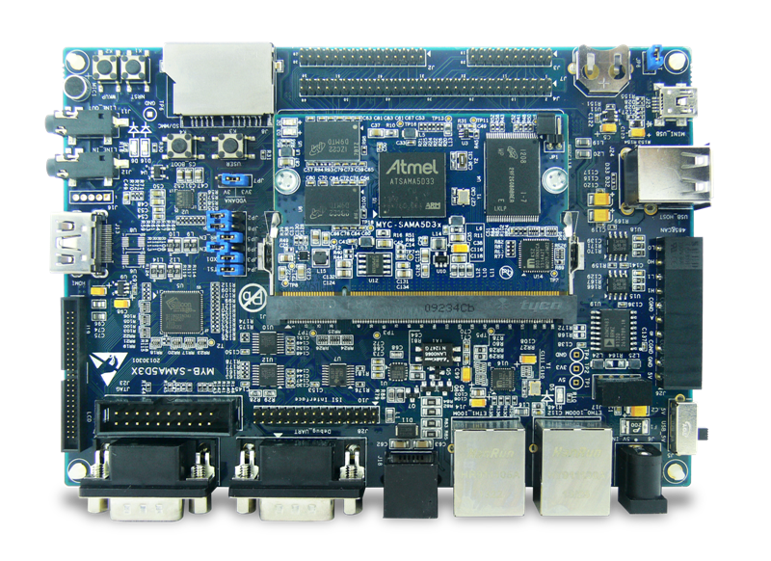

Figure 6‑1 MYD-JA5D4X

# Appendix 1 Warranty & Technical Support Services

**MYIR Tech Limited** is a global provider of ARM hardware and software tools, design solutions for embedded applications. We support our customers in a wide range of services to accelerate your time to market.

MYIR is an ARM Connected Community Member and work closely with ARM and many semiconductor vendors. We sell products ranging from board level products such as development boards, single board computers and CPU modules to help with your evaluation, prototype, and system integration or creating your own applications. Our products are used widely in industrial control, medical devices, consumer electronic, telecommunication systems, Human Machine Interface (HMI) and more other embedded applications. MYIR has an experienced team and provides custom design services based on ARM processors to help customers make your idea a reality.

The contents below introduce to customers the warranty and technical support services provided by MYIR as well as the matters needing attention in using MYIR’s products.

**Service Guarantee**

MYIR regards the product quality as the life of an enterprise. We strictly check and control the core board design, the procurement of components, production control, product testing, packaging, shipping and other aspects and strive to provide products with best quality to customers. We believe that only quality products and excellent services can ensure the long-term cooperation and mutual benefit.

**Price**

MYIR insists on providing customers with the most valuable products. We do not pursue excess profits which we think only for short-time cooperation. Instead, we hope to establish long-term cooperation and win-win business with customers. So we will offer reasonable prices in the hope of making the business greater with the customers together hand in hand.

**Delivery Time**

**MYIR will always keep a certain stock for its regular products. If your order quantity is less than the amount of inventory, the delivery time would be within three days; if your order quantity is greater than the number of inventory, the delivery time would be always four to six weeks. If for any urgent delivery, we can negotiate with customer and try to supply the goods in advance.**

**Technical Support**

**MYIR has a professional technical support team. Customer can contact us by email (**[support@myirtech.com](mailto:support@myirtech.com)**), we will try to reply you within 48 hours. For mass production and customized products, we will specify person to follow the case and ensure the smooth production.**

**After-sale Service**

**MYIR offers one year free technical support and after-sales maintenance service from the purchase date. The service covers:   
1. Technical support service**

1. MYIR offers technical support for the hardware and software materials which have provided to customers;
2. To help customers compile and run the source code we offer;
3. To help customers solve problems occurred during operations if users follow the user manual documents;
4. To judge whether the failure exists;
5. To provide free software upgrading service.

However, the following situations are not included in the scope of our free technical support service:

1. Hardware or software problems occurred during customers’ own development;
2. Problems occurred when customers compile or run the OS which is tailored by themselves;
3. Problems occurred during customers’ own applications development;
4. Problems occurred during the modification of MYIR’s software source code.

2. After-sales maintenance service

The products except LCD, which are not used properly, will take the twelve months free maintenance service since the purchase date. But following situations are not included in the scope of our free maintenance service:

1. The warranty period is expired;
2. The customer cannot provide proof-of-purchase or the product has no serial number;
3. The customer has not followed the instruction of the manual which has caused the damage the product;
4. Due to the natural disasters (unexpected matters), or natural attrition of the components, or unexpected matters leads the defects of appearance/function;
5. Due to the power supply, bump, leaking of the roof, pets, moist, impurities into the boards, all those reasons which have caused the damage of the products or defects of appearance;
6. Due to unauthorized weld or dismantle parts or repair the products which has caused the damage of the products or defects of appearance;
7. Due to unauthorized installation of the software, system or incorrect configuration or computer virus which has caused the damage of products.

Warm tips:

1. MYIR does not supply maintenance service to LCD. We suggest the customer first check the LCD when receiving the goods. In case the LCD cannot run or no display, customer should contact MYIR within 7 business days from the moment get the goods.
2. Please do not use finger nails or hard sharp object to touch the surface of the LCD.
3. MYIR suggests user purchasing a piece of special wiper to wipe the LCD after long time use, please avoid clean the surface with fingers or hands to leave fingerprint.
4. Do not clean the surface of the screen with chemicals.
5. Please read through the product user manual before you using MYIR’s products.
6. For any maintenance service, customers should communicate with MYIR to confirm the issue first. MYIR’s support team will judge the failure to see if the goods need to be returned for repair service, we will issue you RMA number for return maintenance service after confirmation.

3. Maintenance period and charges

a) MYIR will test the products within three days after receipt of the returned goods and inform customer the testing result. Then we will arrange shipment within one week for the repaired goods to the customer. For any special failure, we will negotiate with customers to confirm the maintenance period.

b) For products within warranty period and caused by quality problem, MYIR offers free maintenance service; for products within warranty period but out of free maintenance service scope, MYIR provides maintenance service but shall charge some basic material cost; for products out of warranty period, MYIR provides maintenance service but shall charge some basic material cost and handling fee.

4. Shipping cost

During the warranty period, the shipping cost which delivered to MYIR should be responsible by user; MYIR will pay for the return shipping cost to users when the product is repaired. If the warranty period is expired, all the shipping cost will be responsible by users.

5. Products Life Cycle

MYIR will always select mainstream chips for our design, thus to ensure at least ten years continuous supply; if meeting some main chip stopping production, we will inform customers in time and assist customers with products updating and upgrading.

**Value-added Services**

1. MYIR provides services of driver development base on MYIR’s products, like serial port, USB, Ethernet, LCD, etc.
2. MYIR provides the services of OS porting, BSP drivers’ development, API software development, etc.
3. MYIR provides other products supporting services like power adapter, LCD panel, etc.
4. ODM/OEM services.



**MYIR Tech Limited**

Room 1306, Wensheng Center, Wenjin Plaza,

North Wenjin Road, Luohu District, Shenzhen, China 518020

Support Email: [support@myirtech.com](mailto:support@myirtech.com)

Sales Email: [sales@myirtech.com](mailto:sales@myirtech.com)

Phone: +86-755-22984836

Fax: +86-755-25532724

Website: www.myirtech.com